5/30/2014

Neilson Leslie

Bryan Pope

Brandon Coulthard

Andrew Best

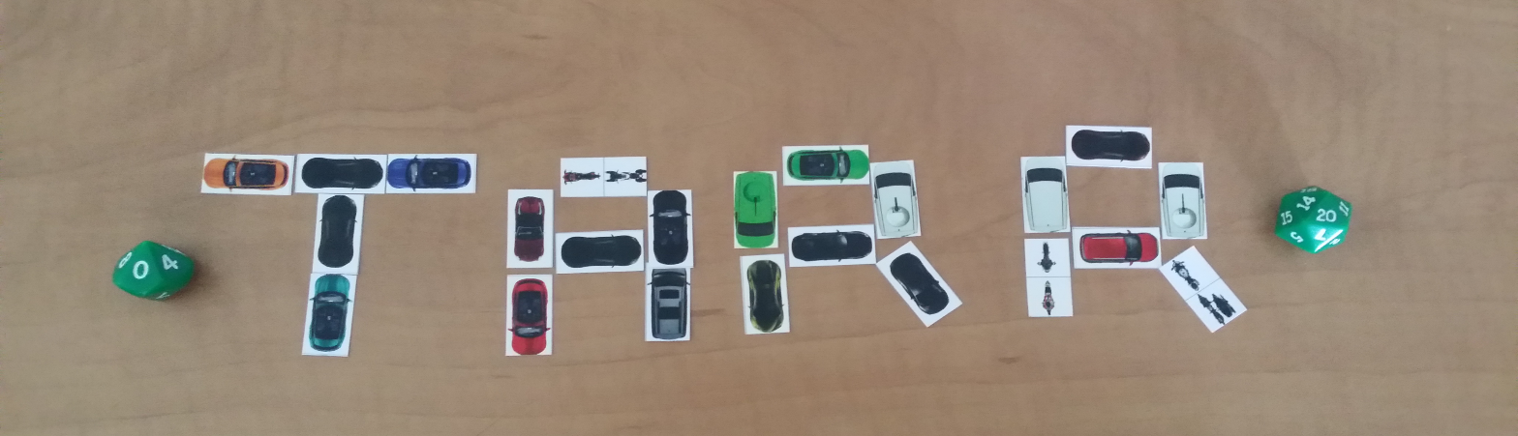

TOTAL APOCALYPSE ROAD RAGE

Game Design Document

Version 1.0

Contents

1. Game Overview 3

1.1 Objective 3

1.2 Genre 3

1.3 Audience 3

1.4 Platform/Minimum System Requirements 3

2 Plot & Setting Information 3

2.1 The Story 3

3 Core Gameplay 3

3.1 Map Level 3

3.2 In Battle 4

3.3 Road Combat 4

3.3.3 Crew Deployment 4

3.3.5 Tactical Combat 4

4 Environment Elements 4

4.1 Environment 4

4.1.1 List of Cities 4

4.1.2 Terrains 6

4.2 Vehicles 8

4.2.1 Vehicle Attributes 8

4.2.2 Maintenance 9

4.2.3 Improvements 9

4.3 Supplies 9

4.3.1 Carrying Capacity 9

4.3.2 Consumption 9

4.3.3 Caches 9

4.3.4 Special Supplies 9

4.4 People 10

4.4.1 Gangs 10

4.4.2 Encounters 10

5 Interface Usage 12

5.1 Controls 12

6 Menu and General Game Usage 12

6.1 Screen Descriptions 12

6.2 Game Flow Diagram 15

7 Audio 16

7.1 SFX 16

7.2 Music 16

# Game Overview

## Objective

You lead a gang of trained men in specially prepared vehicles through the missile remains of devastated Canada. Search out agents of the anti-Rob Ford underground and obtain clues on the whereabouts of Rob Ford's headquarters. Once you've found the headquarters and engage Rob Ford's gang leaders in a climactic battle to decide the future of Canada!

## Genre

Total Annihilation Road Rage is a Turn-based Strategy game.

## Audience

Due to the minimal amounts of violence, Total Annihilation Road Rage is targeting everyone over the age of 10 with Android devices.

## Platform/Minimum System Requirements

Android 2.2 (Froyo) and higher

# Plot & Setting Information

## The Story

On October 31, 2020, Canada gathered to celebrate their beloved holiday Halloween thinking it would be like any other year, however, they were wrong. As everyone got ready for the national holiday an unexpected alarm rang through the streets all across the country. The people gathered and panicked not knowing what was happening, children screaming, mothers weeping, fathers drinking not knowing what to do. The citizens soon realized that the culprit behind this panic was no other than Mr. Rob Ford.

During the Toronto mayor election Rob Ford decided to reward himself for not doing drugs for the past week but lighting himself a crack pipe. Little did he know this would be the destruction of Canada. After blazing it up, Mr. Rob Ford while in a drunken stupor fell onto the hidden button located at the election office which launched missiles all across the country, destroying most of Canada. Unable to deal with the stress Rob Ford gathered his posse and headed out of Toronto so he would not take the blame.

Over ninety percent of Canada was obliterated from the launch leaving less than thousands alive. Who will survive? Who will rise to the challenge and bring Rob Ford to justice? At this point nobody knows..

# Core Gameplay

## Map Level

Every action performed in the overhead map, takes some time but more importantly at least one of your resources is consumed. For example, your food resource is constantly depleted at a fixed number proportionate to the number of people you have in your group.

Other global conditions that can occur as the player progresses are weather conditions (snow, rain, tornadoes, etc.). When the player does an action, there is a random chance that there is an impact from the current weather condition. There are also the random generated cases of sickness/disease and attacks from other gangs.

On the overhead map, the player moves by first selecting his vehicular avatar and then select the destination. The amount of resources that will be consumed for that trip will be shown and the user will have to confirm their action. The vehicle will move from its current location to the destination or as far as the fuel will allow you to travel. Once it reach the destination for the first time, it auto search for loot, people, vehicles. Being on a tile textured with particular material can increased the chances of finding particular resources.

The player can select the avatar and an option list scrolls up from the bottom of the screen. The option list is:

* Move – Once you choose this option, you can then finger point and select your next destination.
* Search – Once you have moved to a location, you may not want to move right away on next turn. So you can search for more loot, vehicle or people.

So a swipe from the side can bring your current inventory into view and swiping in the opposite direction would remove it so the map becomes in focus and full again.

## In Battle

**Move Phase**

Turn Left

Current Speed

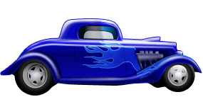

Move

Brake

Accelerate

30

Turn Right

There is a Move all will move all your vehicles in the direction they are facing.

## Road Combat

### Tactical Combat



In the attack phase you will select your vehicle to show a UI that shows where the vehicle can attack. After selecting your vehicle any enemies in range of it will turn bright red indicating that you can attack that vehicle. Press down on a vehicle in your line of sight and then select one of the three options to attack either the exterior, interior, or the tires of that vehicle. After you attack your vehicle will not be able to attack again until the next attack phase. Continue this until all your vehicles have attacked or you skip the phase.

Defence:

Missile Protection Factor

0 – 0% (None)

1 – 20%

2 – 40%

3 – 60%

4 – 80%

5 – 100%

Defence:

Vehicle Size

S – 4

M – 1

L – 0.5

Gang Members:

Modifiers---> Attack Defence

A: Armsmaster +2 +4

B: Bodyguard +1 +3

C: Commando 0 +2

D: Dragoon -1 +1

E: Escort -2 0

Crossbows – max distance of 5 spaces

Guns- max distance of 10 spaces

Range Modifiers:

Distance Crossbow Guns

1 0 0

2 +2 +1

3 +4 +2

4 +6 +3

5 +8 +4

6 N/A +5

7 N/A +6

8 N/A +7

9 N/A +8

10 N/A +9

Combat Resolution:

Figure out combat bonus for gang member type which is currently attacking.

For an Armsmaster using a gun with a distance of 4, this would be:

Attack bonus is +2, range penalty is -3, so attack bonus is 2-3 = -1

d20 is rolled. A 1 is always a miss and a 20 is always a hit. Otherwise, the roll is then added to the attack bonus. So if a 12 is rolled, the modified roll would be 11.

Then a random number is generated to decide the type of gang member that is being attack. If there are 3 different types of gang members being shot at, the random number is between 1 and 3.

Then by the type of gang member being attacked, we can find out if they are successfully hit.

If an Escort is being shot at their defensive bonus is calculated as follow:

10 + 0 for a total defensive bonus of 10. So with the Armsmaster rolling a 11 and an Escort being rolled as who is being shot at, the Armsmaster has successfully killed this Escort.

But if you are shooting the interior of a vehicle and it has a missile protection factor, then we need to check to see if it protected that occupant. This is a simple d100 roll and see if it is lower than the vehicle's protection factor. If the number rolled is, that attack did not succeed.

# Environment Elements

## Environment

## 

### Terrains

**Desert.** Plains represent range land and other rural terrain not primarily used for agriculture. Roads are few and of poor quality and travel is slow. Establishments are few and far between. People are scarce.



**Grass.** Farmland represents land primarily used for agriculture. Roads are poor, slowing travel. Farms are very common and road gangs sometimes raid for food. Other people are scarce.

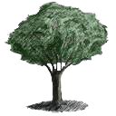

**Woods.** Woods represent areas of virgin forest with few roads and no habitation worth mentioning. A place to be sure of your fuel supply.

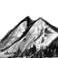

**Mountains.** Mountains are very rugged terrain with no roads. Travel is impossibly difficult.



**Water.** You may be the saviour of Canada, but you can't drive on water.

 **Roads.** Roads represent large autobahns and multi-lane highways. Not all were left intact by the missiles. Many smaller cities and towns dot their lengths. Road gangs may find sufficient supplies for subsistence. Travel is rapid despite numerous wrecks and abandoned vehicles.

**Cities.** Cities come in three sizes: Major Cities, and Towns. The cities are the stomping grounds of a wide variety of social groups, some benign and others quite unsavoury. Supplies are plentiful but can be exhausted. The larger the city, the more inexhaustible the available supplies. Travel is no problem due to the multitude of highways and byways which allow easy bypass of streets choked with wrecks and abandoned vehicles.



**Oilfields.** Oilfields are areas where petroleum was king. Some oilfields are offshore and inaccessible. Road gangs battle daily for access to the vast supplies of fuel available there.

 **Devastated Areas.** These cities destroyed by missiles are unpleasant at best. There is little to be gained in these desolate places. Mutants are a constant danger.

## Vehicles

### Vehicle Attributes

Every vehicle has a set of stats that determines how well a vehicle is fit for battle. They stats are divided into categories to show the player how fast, strong, and maneuverable a vehicle is. An example of how a vehicle stats can look are as follows:

STRUCTURE: 45/45 Strong defence

MANEUVERABILITY: 3/3 Good maneuverability

BRAKING: 3 Slow braking

ACCELERATION: 3 Slow acceleration

WEAPON TYPES: C- Low grade weapon

TIRES: 0/0 No extra tires

SPEED: 7/10 Average speed

FACING: 0 No facing value

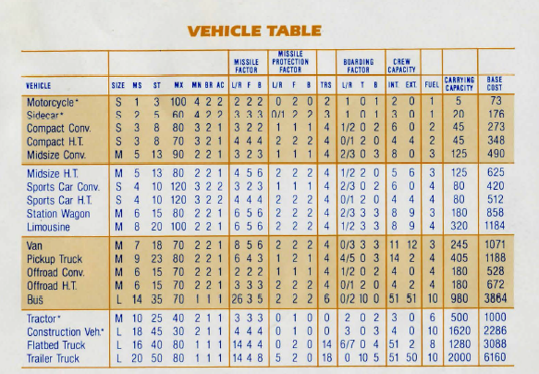

**Abbreviations:**

**MS** =Mass

**ST** =Structure

**MX** =Max Speed in KMH

**MN=** Maneuverability

**BR** =Braking

**AC** =Acceleration

**L/R=** Left or Right Facing

**F** =Front Facing

**B** = Back Facing

**T** =Topside Facing

### Maintenance

1. **Structural Damage.** Vehicles sustain structural damage when they're hit in combat. This damage may only be repaired at various body shops you'll find while searching for loot.
2. **Flat Tires.** Tires lost during combat must be repaired so that the vehicle will regain full manoeuvrability. Flat tires are replaced to the limit of the number of spares your gang is carrying.

### Improvements

Vehicles may be improved during play by the discovery of certain special locations while searching for loot. Some enemy road gangs may drive improved vehicles. You can capture these improved vehicles in

Tactical Combat by boarding and eliminating the enemy crews.

## Supplies

Supplies are obtained by searching for loot and by defeating enemy groups in combat.

### Consumption

Every night each member of your gang eats one unit of food. Each time your gang moves, each vehicle consumes fuel equal to its fuel consumption. Healers require various amounts of medical supplies in exchange for their services. Tires are consumed in repairing battle damage. Every time a member of your gang fires a gun, one round of ammo is expended.

## People

### Gangs

**A Gang Members**

**1. Quality.** Almost all people encountered will be rated Arms master, Bodyguard, Commando, Dragoon, or Escort, in order of decreasing effectiveness. They are often referred to as A B, C, D, and E troops. Members’ quality reflects how likely he is to survive an event and his offensive and defensive powers in combat After being in combat, some or all of your crew may promote to the next highest rating.

1. **Recruiting.** Gang members may be recruited by searching for people and sending envoys. The higher the quality of the prospective gang members the less likely they are to join your gang.

**3. Cronies.** These individuals can be of invaluable aid in your travels. Only one of each will travel with you. If another is encountered and you accept him into your gang, your current specialist will leave. Each of these individual is practices his trade with a varying degree of skill.

1. Doctor. A doctor reduces your casualties from disease, from accidents, and in foot combat. The better the doctor, the fewer casualties you'll take. You must judge his effectiveness from his work.
2. Drill Sergeant. A drill sergeant increases the number of members who promote after combat and decreases your loses to desertion and recklessness.
3. Politician. A politician can *serve* as your envoy in foot gang encounters and as a liaison with bureaucrats. He can even talk a lesser politician out of offering to join.

### Encounters

These are the special encounters you may have

While searching for people:

**1. Agents.** Agents of the Anti-terrorist Underground may be encountered. They are unlikely to reveal themselves under normal conditions. When they reveal themselves, take notes and follow their advice carefully.

**2. Healers.** The healers are the remnants of the medical community. Bound together by their common oath, they have gathered into informal research groups to aid the sick and injured and research remedies to the disease. They ask only to be kept supplied with medical goods and to be left alone. They heal all who seek their *services.* They have come up with an assortment of antitoxins which will cure mutant infections. They live primarily in cities where their needs for research materials can be met more easily.

1. **Foot Gang Commands.** When you encounter a group on foot you have four options:

a. Sending Envoys. A dangerous mission, but the best way of gaining recruits. Showing strength can prove beneficial. If you have a good politician he may save you the trouble of sending troops.

b. Firing a Volley. This is the ultimate show of strength. It also tends to cause bad feelings among the recipients and can precipitate a firefight.

c. Waiting. Waiting will be taken by some as a sign of weakness.

d. Leaving. A sign of weakness understood by all.

**4. Foot Gangs.** The different types of gangs you'll encounter on foot include:

a. Soldiers. Soldiers are isolated units of military personnel. It is dangerous to quarrel with them, but it's seldom necessary as they are willing to join in a good cause.

b. Hoodlums. Hoodlums are a mixed lot of marginal character. They are generally well led but poorly disciplined.

c. Home Guard. Home Guard units consist of poorly trained and equipped militia. Little better than an armed rabble, they can be unpredictable.

d. Civilians. Mobs of cowering and inoffensive souls. Many will want to join you if you want them.

e. Cannibals. These throwbacks have taken the easy route to solving the food problem. They are wily and are fond of ambushing envoy parties. The scum of the earth.

1. **Residents.** In cities you’ll encounter gangs like:

a. Police. A few cities are still under the control imposed by civil authorities. These officers are well armed and well trained

b. Bureaucrats. Occasionally, local governments maintain control of their municipalities with the aid of local law enforcement agencies. Passers-by are often charged tolls under a threat of force.

c. Terrorists. The majority of cities are controlled by terrorists, either openly or via the subversion of local authorities. Terrorists come in many stripes: Regulars, Irregulars, Collaborators, Sympathisers, Provocateurs and the dreaded Terrorist Elite.

d. Neutrals. These pleasant folk have a single aim; they wish to live in peace. They will never provoke a fight and anything they have is yours for the asking

e. Mutants. Mutants are diseased, psychotic zombies who want to tear all healthy people to bits. They roam only at night. They are very quiet and very dangerous. They have the filthy habit of transmitting their disease to their victims.

1. **Rob Ford Gangs.** On the road you'll meet:

a. Ford Patrols. Patrols of terrorist troops of varying quality roam the highways in order to stifle transportation. These patrols may be of Irregular troops, Regular troops. or the feared Terrorist Special

Battalions.

b. Crack addicts. Ever *see* a slime drive a car? These vermin fit the bill. They are poorly armed and easily dispatched.

# Interface Usage

## Controls

On the overview map, the player has limited control to press on the surface on the device to select an object, option or location. Swiping the right edge of the screen allows for the player to view or close their inventory screen

# Menu and General Game Usage

## Screen Descriptions

1. The Main Menu screen gives the user the option to make an input to navigate to other screens; Start Game, How to Play, Tactical Combat or Credits.

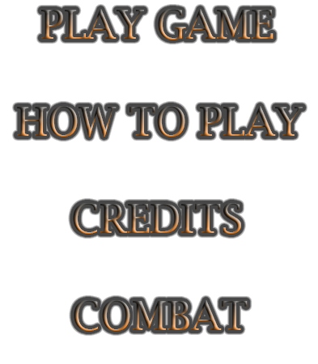

1. How to play launches a series of screens to explain the game.
2. Credits will display the members involved in the game.
3. Combat will take you directly into tactical combat.

## Game Flow Diagram

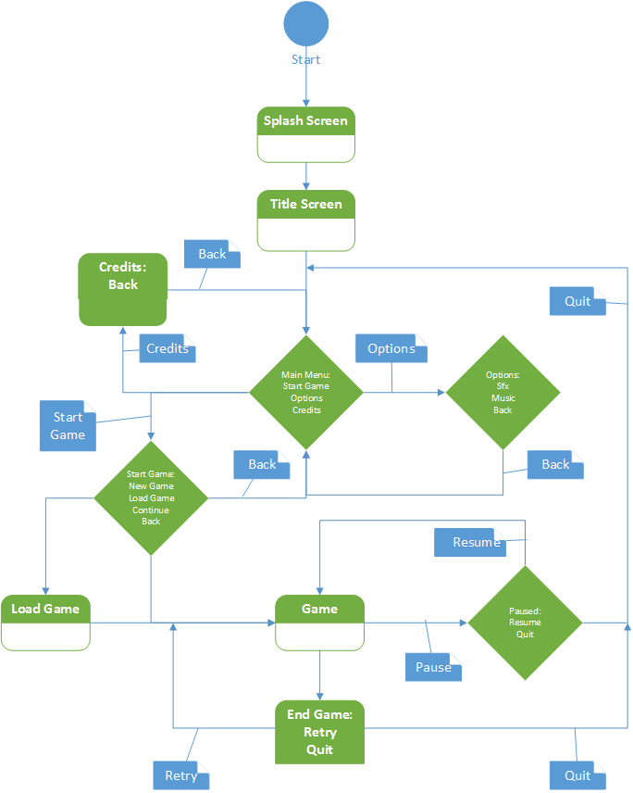

# Audio

## SFX

Guns will have different sound effects tied to them based on what weapon is fired. As well when vehicles crash into something there will be a sound effect that gives the user a sense that the vehicle slammed into the object.

## Music

The style of music that TARR will use is industrial 8-bit style music that gives the player a sense that they are playing a classic turn based strategy game with heavy metal background music.